**Strength analysis of molten salt tanks for CSP plants** **Electric-thermal-fluid Multiphysics Simulation of PT Micro-heater Chip Subjected to Constant/Pulsed Current**

**Yi-Gao Lv1, Lin-Ying Ren2, Qiu-Wang Wang1 and Wen-Xiao Chu1\***

1 Key Laboratory of Thermo-fluid Science and Engineering, Ministry of Education, Xi’an Jiaotong University, Xi’an, Shanxi 710049, China

2 State Key Laboratory of Electrical Insulation and Power Equipment, Xi’an Jiaotong University, Xi’an, Shanxi 710049, China

***Corresponding author (Wenxiao Chu, wxchu84@xjtu.edu.cn)***

**Full Abstract**

Microelectromechanical systems (MEMS) technologies have been actively developed over the past two decades. Microscale heaters are key components of such technologies, which provide fast controlled heating of micro-volumes of medium to the required temperature level [1]. When the micro-heater is exposed to the liquid such as deionized water and FC-72, microscale boiling and transient bubble nucleation phenomena will be observed. Over the last decades, some researches have been performed to investigate the microscale boiling phenomena under either pulsed or constant heating conditions and the differences in the mechanisms between the conventional macroscale and microscale boiling and bubble nucleation [2]. Generally, many factors, such as the shape of the micro-heater and the heating conditions, are recognized to play a dominant role in the microscale boiling process. Leung et al. [3] observed two groups of boiling patterns generated by a set of different sizes of micro-heaters. Since the vapor in the bubble could be condensed outside the superheated region, the different boiling patterns and bubble dynamics was thought to be greatly dependent on the shape and size of the superheated region.

Supercritical water has received widespread attention due to its special physical and chemical properties. In some reactors related to supercritical water technology, such as supercritical water gasification, natural convection is a factor needing to be considered because of the high thermal compressibility of supercritical water. In this paper, numerical method is applied to analyze the natural convection and heat transfer characteristics of supercritical water in a side-wall heated cylinder. In order to match the actual situation, an inlet and an outlet are added to the bottom and the top of the cylinder respectively. After that, the quasi-DNS method is used for numerical simulation, and the thermodynamic properties of supercritical water are calculated by IAPWS-IF97 formulations. As a result, the flow structures and temperature inside the cylinder are analyzed. The characteristics and influence of the flow boundary layer are specially studied. Finally, a heat transfer correlation of supercritical water natural convection is proposed, and ways of heat transfer enhancement are discussed.

**Keywords:** *Supercritical water*, *Natural convection*, *Heat transfer*

**Abstract figure (if available):**

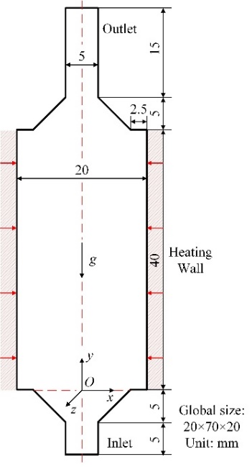

**Fig.1.** The sectional view of the physical model.